**DDD - Domain Driven design**

* Domain-Driven Design (DDD) is a software development approach that focuses on aligning the structure and language of software with the business domain it serves.
* It mainly focuses on creating a domain model that accurately reflects business rules and concepts, improving software quality and usability.
* DDD helps navigate complex systems by breaking them down into smaller, manageable bounded contexts with their own models.
* For example, E-commerce, with entities like Product, Order, and Customer.

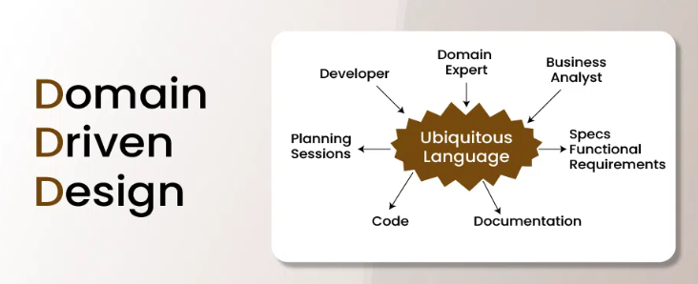

**TDD - Test Driven Design**

* Test-Driven Development (TDD) is a software development approach where automated tests are written before the corresponding code is written.
* This iterative process of writing tests, seeing them fail, writing code to make them pass, and then refactoring, ensures that code is reliable, maintainable, and well-designed.
* In TDD, developers write small, focused tests that define the desired functionality, then write the minimum code necessary to pass these tests, and finally, refactor the code to improve structure and performance.
* **Example**: Building a Login System.

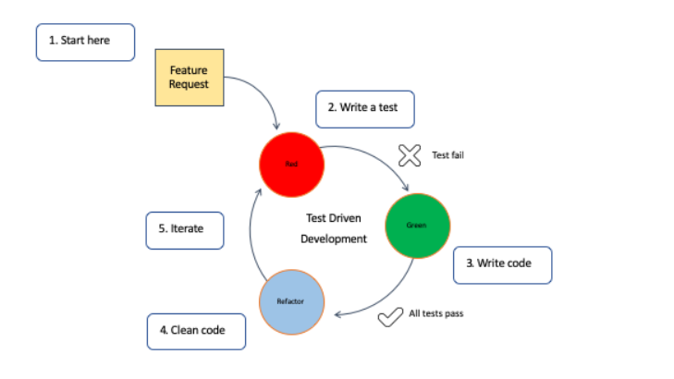

**BDD - Behaviour Driven Design**

* Behaviour-Driven Development (BDD) is a software development methodology that emphasizes collaboration and a shared understanding of requirements between developers, testers, and business stakeholders.
* It uses a natural language-based format, often called as "Given-When-Then", to define application behaviour through scenarios and examples.
* This approach promotes clear communication, facilitates testing, and helps ensure that the software meets user expectations.

**FDD – Feature Driven Design**

* Feature-Driven Development (FDD) is an Agile software development methodology that focuses on delivering working software with specific, client-valued features.
* It emphasizes iterative and incremental development, breaking projects into smaller, manageable units (features).
* FDD is known for its structured approach, which helps large teams and complex projects by combining traditional planning with Agile build practices